5-SSB:

MATLAB Code for this part :

fs = 120; %sample frequency

fc= 50 ;%carrier frequency

ts=1/fs;

t=0:ts:3 ;

m_t = cos(2*pi*9*t);% signal

c_t =cos(2*pi*fc*t);%carrier

c_t2=sin(2*pi*fc*t);

hil = hilbert(m_t);%heilbert transform

mh_t = imag(hil); %signal heilbert

usb=m_t.*c_t -(mh_t.*c_t2); %usb signal

usbzp=[usb zeros(1,2000)];

%Drawing usb in freq:

usbzpf = (ts/3).*fft(usbzp);

usbsh=abs(fftshift(usbzpf));

N = length(usbzp);

df=fs/(N-1);

f=-(fs/2):df:(fs/2);

figure

plot(f,usbsh)

xlabel ('f');

ylabel ('Spectrum');

%demodulation

%After coherent detector

N1 = length(usb);

df1=fs/(N1-1);

f1=-(fs/2):df1:(fs/2);

signal=usb.*c_t;

signalf=(ts/3)*fftshift(fft(signal));

LPF=rectangularPulse(-10,10,f1);

signalfn=signalf.*LPF;

mt=3*fs*ifft(ifftshift(signalfn));

figure

plot(t,m_t,'color','g')

hold on

plot(t,mt,'color','r')

hold off

legend('Original Signal','Signal Received')

xlabel ('t');

ylabel ('Signal');

a)the spectrum of the USB modulated signal:

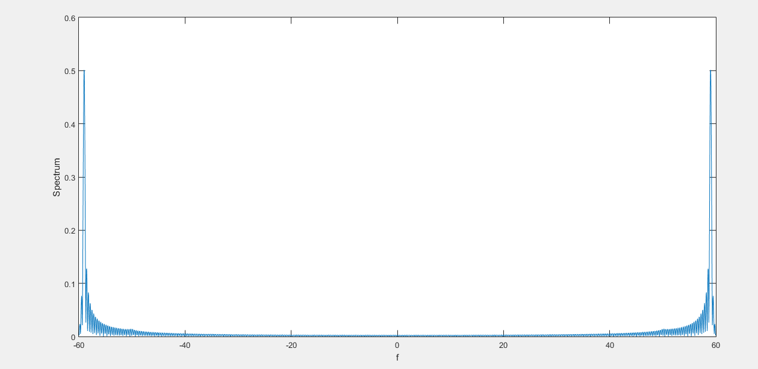

Estimated BW = W = 9 HZ

b)YES it can be demodulated :

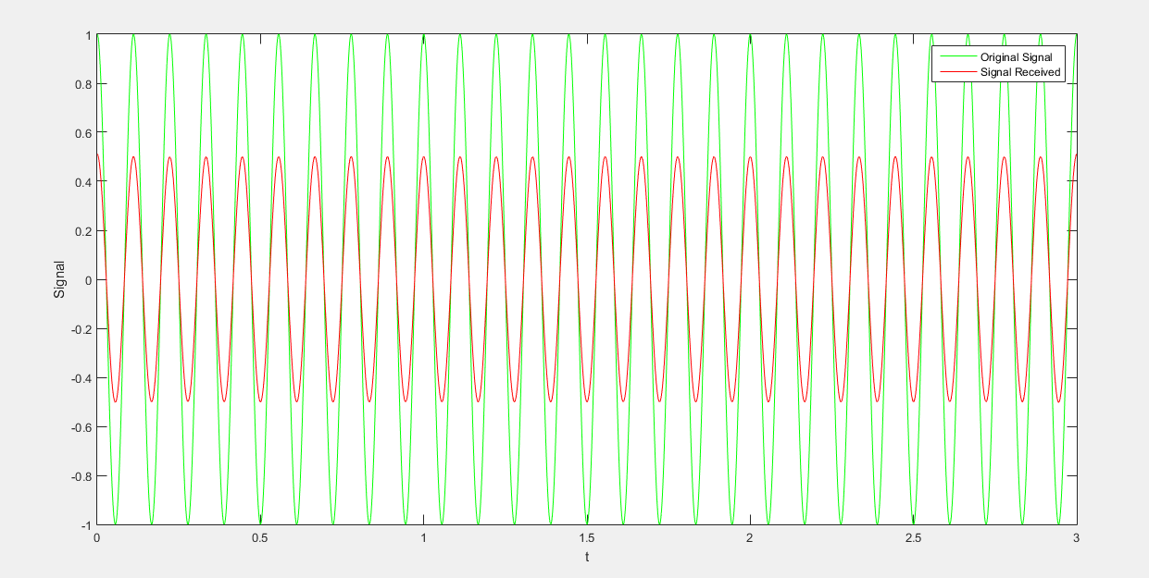

8-FM:

MATLAB code:

fc = 50 ; % carrier-frequancy = 50 HZ

Kf = 20 ; % sensitivity = 10 Hz/V

fm = 9 ; %signal_frequancy = 9 Hz

t =0:0.004:3 ;

m = cos (2*pi*fm.*t);%signal

m_integ =0.004*cumtrapz(m) ;%signal integral

plot(t,m_integ)

c= cos ( 2*pi*fc.*t);%carrier

s =cos(2*pi*fc.*t +(Kf).*m_integ);%modulated signal

fi= fc + (Kf/2*pi)*m ; %instantaneous frequency

figure

subplot(2,1,1)

plot(t,s);

xlim([0 3])

xlabel ('t');

ylabel ('FM signal:s(t)');

subplot(2,1,2)

plot (t,fi);

xlabel ('t');

ylabel ('instantaneous frequency:fi(t)');

Plots:

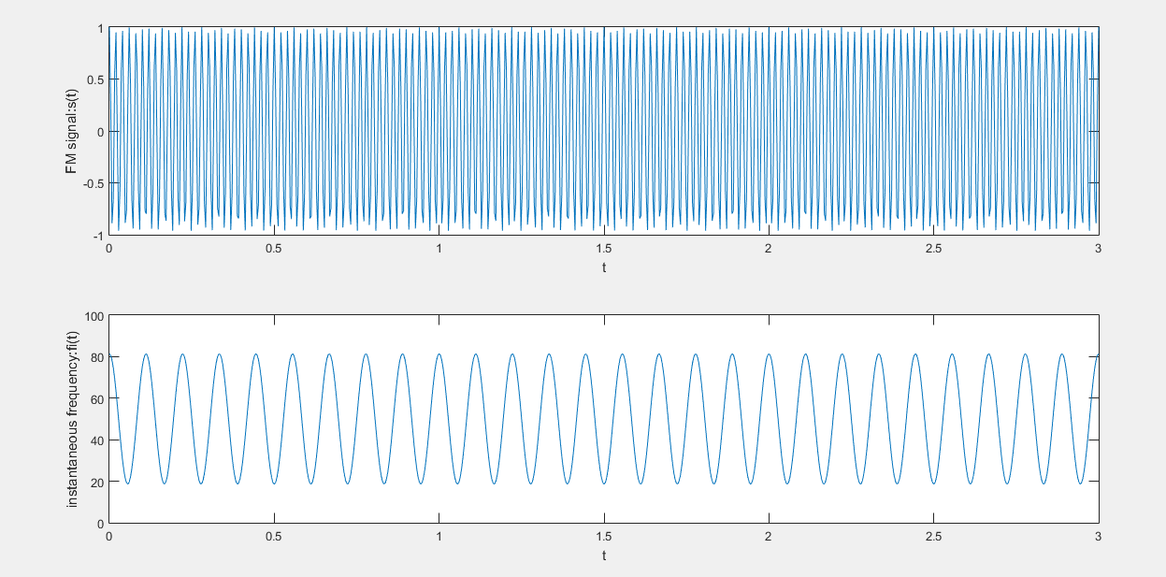

6. Conventional AM (DSB-LC) modulation:

Matlab code:  
clear

clc

close all

ts = 0.003;

fs = 1/ts;

t = 0:ts:3;

ka = 1.5;

fm = 9;

fc = 50;

R = 10^4*4;

C = 10^-6;

mt = cos(2*pi*fm*t);

V = length(mt);

%mt = [mt zeros(1,200)];

ct = cos(2*pi*fc*t);

St = (1+ka*mt).*ct;

N = length(t);

%x = [x zeros(1,200)];

y =(1/3*ts).*fftshift(fft(St));

M = length(y);

df = fs/(V-1);

f = -fs/2:df:fs/2;

z =(1/3*ts).*fftshift(fft(mt));

envelope = (1+ka*mt);

%Vc = (1+ka1*mt).*(1-(t/RC));

Vct(1) = St(1);

for i=2:length(St)

if St(i)>Vct(i-1)

Vct(i)=St(i);

else

%Vct(i)= Vct(i-1).*(exp(-ts/(R*C)));

Vct(i)= Vct(i-1).*(1-(ts/(R*C)));

end

end

v =(1/3*ts).*fftshift(fft(Vct));

subplot(6,1,1)

plot(t,mt)

title('the orginal signal');

xlabel('time (s)');

ylabel('amplitude');

subplot(6,1,2)

plot (t,St)

title('the AM modulated signal');

xlabel('time (s)');

ylabel('amplitude');

subplot(6,1,3)

plot (f,abs(y))

title('Spectrum of the AM modulated signal');

xlabel('frequency (Hz)');

ylabel('amplitude');

subplot(6,1,4)

plot(t,St)

hold on

subplot(6,1,4)

plot (t,envelope)

title('Envelope detector output of AM signal "ideal"');

xlabel('time (s)');

ylabel('amplitude');

legend('St','envelope')

hold on

subplot(6,1,5)

plot(t,St)

hold on

subplot(6,1,5)

plot(t,Vct)

title('Envelope detector output of AM signal "practical"');

xlabel('time (s)');

ylabel('amplitude');

legend('St','Vct')

subplot(6,1,6)

plot(t,mt)

hold on

%plot(t,envelope)

subplot(6,1,6)

hold on

subplot(6,1,6)

plot(t,Vct)

title('the orginal signal & Envelope detector output of AM signal "practical"');

xlabel('time (s)');

ylabel('amplitude');

legend('mt','Vct')

figure

subplot(2,1,1)

plot(t,mt)

hold on

subplot(2,1,1)

plot(t,Vct)

title('the orginal signal & Envelope detector output of AM signal "practical"');

xlabel('time (s)');

ylabel('amplitude');

legend('mt','Vct')

subplot(2,1,2)

plot (f,abs(z))

hold on

subplot(2,1,2)

plot (f,abs(v))

title('Spectrum of the orginal signal & Envelope detector output');

xlabel('frequency (Hz)');

ylabel('amplitude');

legend('abs(z)','abs(v)')

figures: for Ka=0.4

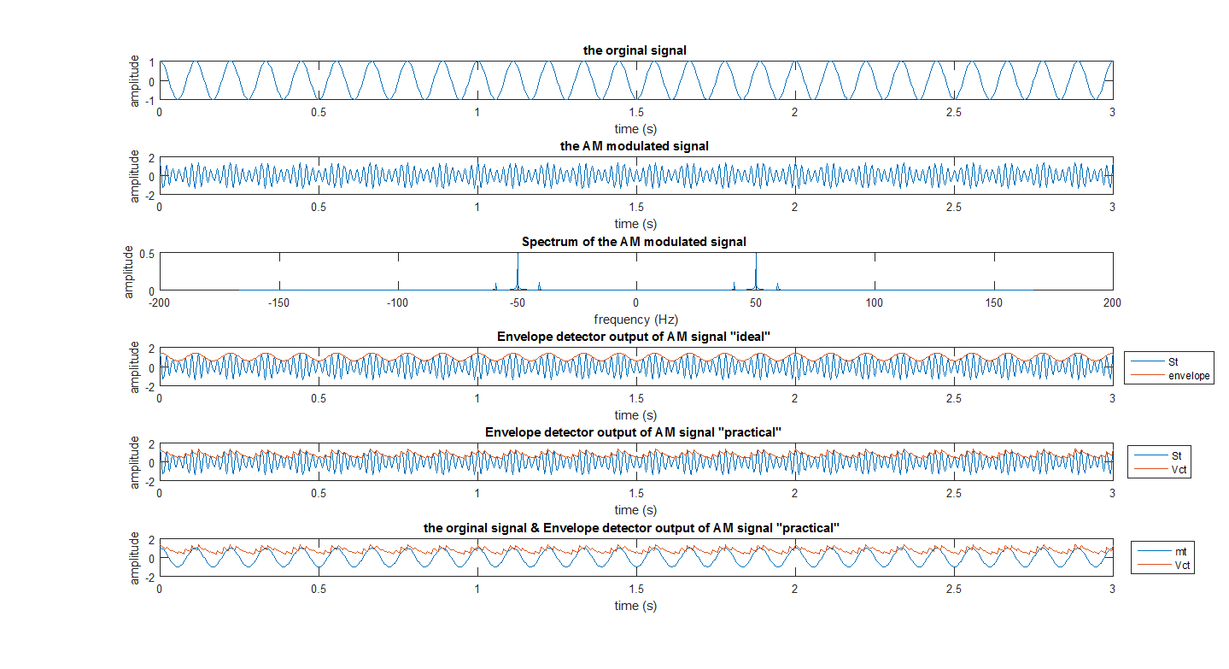

for Ka=0.4

comment:  
as Ka>1, the demodulated signal is not correct ,due to phase revasals

Plot the demodulated signal and the original message on one graph both in time

domain and in frequency domain.

  
by using lowpass filter to enhance the demodulated signal such that it resembles the original message.

Determine the best relaxation time (t) of the envelop detector such that demodulated signal is very close to the original message : $\frac{1}{ω_{c}}≤RC≤\frac{1}{ω_{m}}×\frac{\sqrt{1-μ^{2}}}{μ},where:μ=Ac*Ka,Ac=1,Ka=0.4,so:0.003≤RC≤0.04$